Email 1 — Initial Announcement
Subject: Important Travel Update for March 2026 ASD Show — Plan Ahead
Good morning,
I wanted to reach out (along with several other brands) personally to make sure you’re aware of some important changes regarding the March 2026 ASD Show that could affect your travel and planning.
The official show dates are now confirmed for:
- Closeout Preview Day: Monday, March 16, 2026 (8 AM – 6 PM)
- Show Dates: Tuesday, March 17 – Thursday, March 19, 2026
Please note — the show has shifted to a midweek format and will strictly enforce its policy prohibiting buyers from entering the show floor before Monday, March 16, 2025.
To make the most of your time and ensure smooth access on Monday, we recommend arriving in Las Vegas on Sunday, March 15. This will prepare you to meet with us and capitalize on early opportunities during Closeout Preview Day.
Best regards,
<Your Name Here>
<Your Logo Here>
<Your contact info here>
<Your contact info here>
<Your contact info here>


Leading Brands Stand Together for a Stronger Show Experience
These brands also proudly support the new schedule and are committed to upholding a consistent, high-quality experience for all attendees by honoring the official show opening time.

Email #2 — Don’t Miss Your Shot!
Subject: Want First Pick? Be There Monday, March 16th
Hi,

Just a quick reminder about the March 2026 ASD Show — it’s coming up fast!
Here’s the big thing to remember: buyers can’t access the show floor until Monday, March 16th.

That’s the start of Closeout Preview Day — you’ll want to be there when doors open. The best deals, product finds, and connections happen here.

Tip: Arrive in Vegas on Sunday, March 15th, so you’re rested and ready to roll first thing Monday morning (badge pick up starts at 7 am, show floor opens at 8 am).

**To make your planning easier, we’ve pulled current hotel rates from Expedia for a 3-night stay (checking in Sunday). There are some excellent deals available right now! All rates were verified as of November 6 on Expedia and are listed as fully refundable. (See the bottom of this email for details.)

Let’s make this your best ASD yet — see you there!

Cheers,
<Your Name Here>

<Your Logo Here>
<Your contact info here>

Leading Brands Stand Together for a Stronger Show Experience
These brands also proudly support the new schedule and are committed to upholding a consistent, high-quality experience for all attendees by honoring the official show opening time.

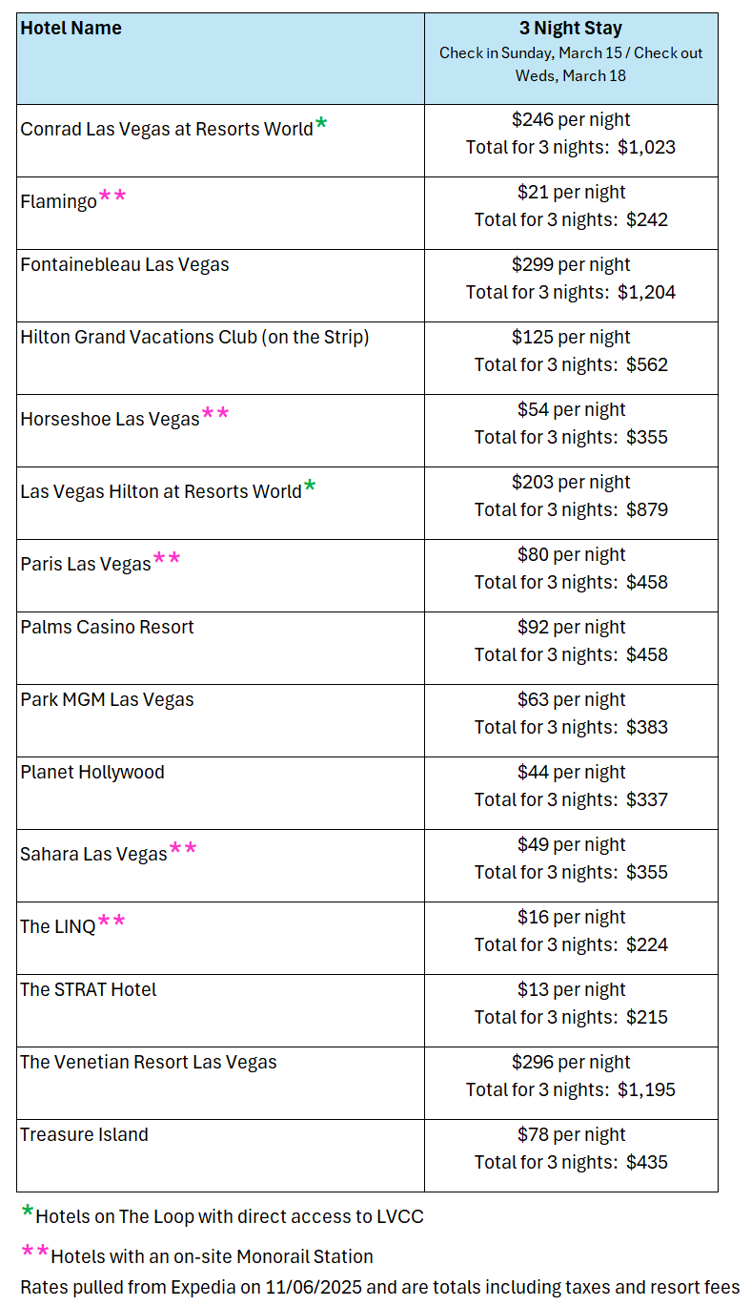
Email #3 — “How to Make Monday Count”
Subject: Be Ready to Hit the Floor Running — Monday, March 16th
Hi again,
The countdown to ASD March 2026 is officially on!
If you’re planning your trip, here’s the most important detail to keep in mind: there will be no buyer access to the show floor before Monday, March 16th.
That Monday is your moment — the official Closeout Preview Day — when serious buyers shop the biggest closeouts and show specials.
Travel & Planning:
- Fly in Sunday, March 15th — skip the Monday morning scramble.
- Book your meetings now for Monday’s preview.
- Plan to stay through Thursday, March 19th, for the full show.
This new midweek schedule is designed to help you maximize every minute — so let’s make it count!
See you soon,
<Your Name Here>
<Your Logo Here>
<Your contact info here>
<Your contact info here>

Leading Brands Stand Together for a Stronger Show Experience
These brands also proudly support the new schedule and are committed to upholding a consistent, high-quality experience for all attendees by honoring the official show opening time.

Email #4 — “Final Reminder: Doors Open Monday Only!”
Subject: The Floor Opens Monday, March 16th — Don’t Miss It
Hi there,
We’re just about ready for the March 2026 ASD Show, and I wanted to send one final reminder before you travel.
Buyer access officially begins Monday, March 16th — no buyers will be allowed in before 8 AM on Monday.
Monday is your time to walk the floor early, connect with top vendors, and grab the best deals before the crowds roll in.
If you haven’t already, make sure your travel plans are to arrive in Las Vegas on Sunday, March 15th, and that you're ready to go bright and early on Monday at 8 am!
Safe travels — see you there!
Best,
<Your Name Here>

<Your Logo Here>
<Your contact info here>
<Your contact info here>

Leading Brands Stand Together for a Stronger Show Experience
These brands also proudly support the new schedule and are committed to upholding a consistent, high-quality experience for all attendees by honoring the official show opening time.

