Email 1 — Initial Announcement
Subject: Important Travel Update for March 2026 ASD Show — Plan Ahead
Good morning,
I wanted to reach out personally to make sure you’re aware of some important changes regarding the March 2026 ASD Show that could affect your travel and planning.
The official show dates are confirmed for Tuesday, March 17 – Thursday, March 19, 2026.
Please note — the show has shifted to a midweek format and will strictly enforce its policy prohibiting buyers from entering our section of the show floor before Tuesday, March 17, 2025.
To make the most of your time and ensure smooth access on opening day, we recommend arriving in Las Vegas on Monday, March 16. This will prepare you to meet with us and capitalize on early opportunities on Tuesday morning.
Best regards,
<Your Name Here>
<Your Logo Here>
<Your contact info here>
<Your contact info here>
<Your contact info here>

Email #2 — Don’t Miss Your Shot!
Subject: Want First Pick? Be There Tuesday, March 17th
Hi,

Just a quick reminder about the March 2026 ASD Show — it’s coming up fast!
Here’s the big thing to remember: buyers can’t access our section of the show floor until Tuesday, March 17th.

Tip: Arrive in Vegas on Monday, March 16th, so you’re rested and ready to roll first thing Tuesday morning (badge pick up starts at 7 am, show floor opens at 9 am).

**To make your planning easier, we’ve pulled current hotel rates from Expedia for a 3-night stay (checking in Sunday). There are some excellent deals available right now! All rates were verified as of November 6 on Expedia and are listed as fully refundable. (See the bottom of this email for details.)

Let’s make this your best ASD yet — see you there!

Cheers,
<Your Name Here>

<Your Logo Here>
<Your contact info here>

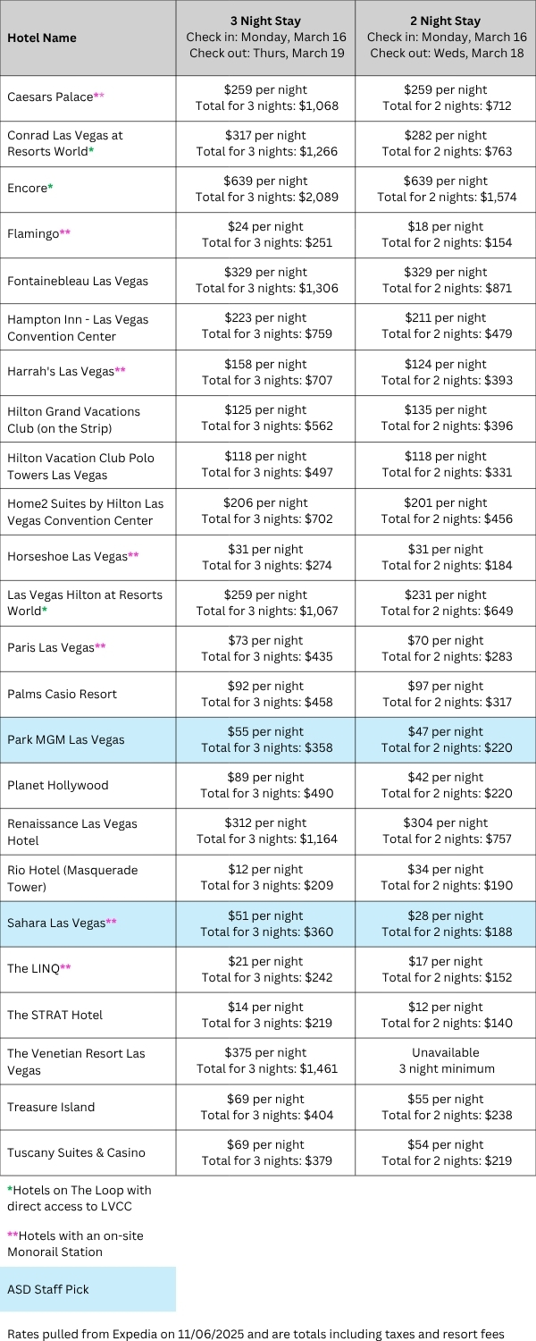

Email #3 — “How to Make Tuesday Count”
Subject: Be Ready to Hit the Floor Running — Tuesday, March 17th
Hi again,
The countdown to ASD March 2026 is officially on!
If you’re planning your trip, here’s the most important detail to keep in mind: there will be no buyer access to our section of the show floor before Tuesday, March 17th.
That Tuesday is your moment to scoop up the best deals right as the doors open.
Travel & Planning:
- Fly in Monday, March 16th — skip the Tuesday morning scramble.
- Book your meetings now for Tuesday.
- Plan to stay through Thursday, March 19th, for the full show.
This new midweek schedule is designed to help you maximize every minute — so let’s make it count!
See you soon,
<Your Name Here>
<Your Logo Here>
<Your contact info here>
<Your contact info here>

Email #4 — “Final Reminder: Doors Open Tuesday!”
Subject: The Floor Opens Tuesday, March 17th — Don’t Miss It
Hi there,
We’re just about ready for the March 2026 ASD Show, and I wanted to send one final reminder before you travel.
Buyer access to our section of the show officially begins Tuesday, March 17th — no buyers will be allowed in before 9 AM on Tuesday.
Tuesday morning is your time to be among the first to walk the show floor, connect with top vendors, and grab the best deals before the crowds roll in later in the day.
If you haven’t already, make sure your travel plans are to arrive in Las Vegas on Monday, March 16th, and that you're ready to go bright and early on Tuesday at 9 am!
Safe travels — see you there!
Best,
<Your Name Here>

<Your Logo Here>
<Your contact info here>
<Your contact info here>

